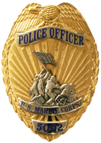
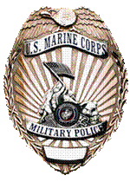
Provost Marshal’s Office
MCBH
House Check Application

The Provost Marshal’s Office’s Crime Prevention Division in conjunction with Police Operations conducts house checks for residents that meet the requirements listed below upon request. House checks help with protecting property and the early detection of burglary, vandalism, and other crimes. A member of the Crime Prevention Division and/or a patrolman will conduct a drive-by and perimeter check of the residence. House checks do not guarantee that the residence will not fall victim to criminal activity and the Provost Marshal’s Office, MCBH, assumes no liability.

Name: ________________________ Date: ____________
SSN #: ________________________
Rank: _________________________
Unit: __________________________

Start Date of House Unoccupied: _______________
End Date of House Unoccupied: ________________

Address: ______________________________________________________
Contact Number(s): ______________ ______________ ______________
Vehicles at Residence: ___________________________________________

Emergency Contact: _____________________________________________

Special Remarks: ________________________________________________

Requirements for House Checks:
- Residence must be unoccupied for (5) consecutive days
- The maximum days a residence can be checked is (30)
- Residence must be completely unoccupied (personal checks by someone indicated on CLEOC Statistics Sheet acceptable)
- Not exact/indefinite return dates unacceptable
- Residence must be a housing unit on MCBH
- Resident must sign up for house checks a week prior to start date

